FOODS 9 NAME:___________________________________
2019-2020 TA____

Learning Guide 8

Holiday Favorites, Part 2: Presenting
January will continue the work that students have been doing, based on consultations and research with family over the break, and other online research.
Learning Outcomes:
On completion of this learning guide you will be able to:
- Make a family traditional food or a food that has become “lost”, after practicing skills related to its creation, using Design methodology to do some initial prototyping.
- Make & bring your dish at home, then bring to school, which will include a visual-based presentation on your project and its historical/cultural/family background

Resources that may be helpful:
- Various YouTube videos on design. Look at the links listed on pg. 3 of the Learning Guide
- Your family & kitchen at home.
- Media Websites including: www.chefsteps.com/activities/developing-a-dish

Activity/Evaluation:
- Week 1: Select a recipe and undertake a prototyping of your dish
- Week 2: Create an end-product and bring or make at school for the class to try (give some to family too)
- Week 2: Present your end-product as part of a sampling “fare”, and include a poster / powerpoint showing details on what you made.
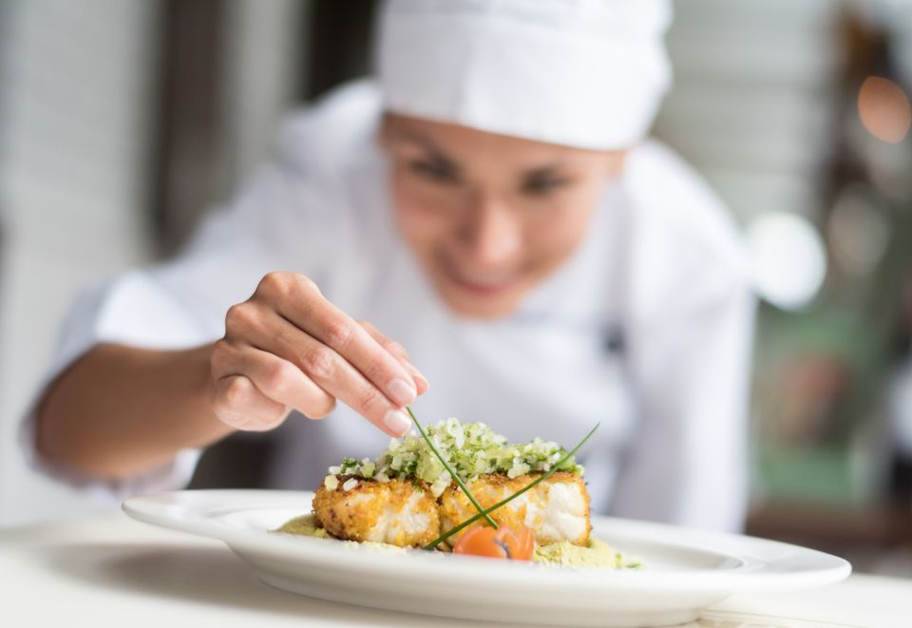

FOOD STUDIES 9 NAME:____________________TA___

Food Traditions -
Brining your food to life using Design thinking
Plan out a Process for creating a Prototype
1. Create a Prototype Plan using The Design Process
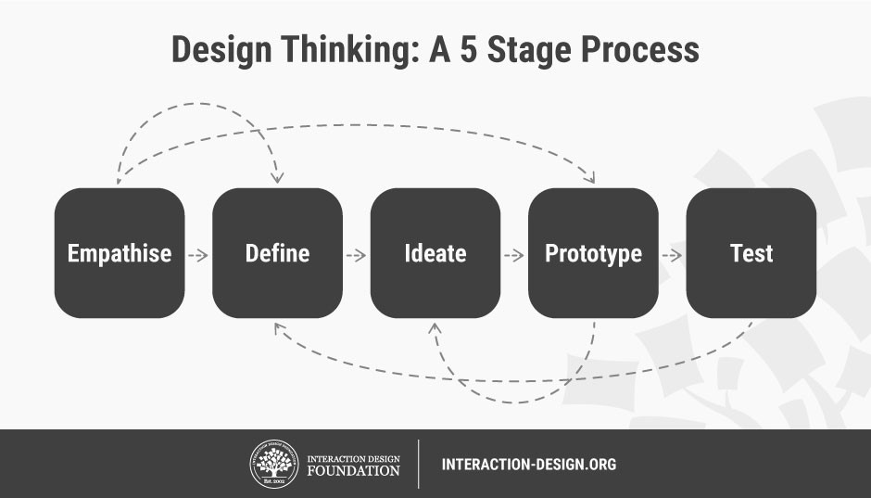
You need to plan out your first attempt at creating your food you researched in LG7.
Using a recipe as foundation for getting started, use the following diagram below and watch/read background on the Design process to brainstorm how you are going to do this.
- Empathise refers to emotively getting to know the end user. In this case it refers to the people your food originated from / are cooking for (example: if food is from grandparents, a question like: “What would my Grandma think of how I have made this dish?” would reflect empathetic thinking).

- Define refers to identifying the exact purpose of what you are trying to do. Are you trying to make an authentic dish, as close to the original as possible? Are you trying to make it taste the best possible for the end user? Are you trying to modify for dietary needs (low-carb etc.)?
- Ideate refers to clarifying how you will achieve your purpose: What specific ingredients will you need, including any alterations? What considerations regarding colouration, texture and “feel” to the meal will you look at? What other foods will be served with this dish? What method of cooking and steps will you utilize?
- Prototype refers to a “practice run”. In order to avoid waste you may attempt the recipe as a small batch (i.e. divide all ingredient measurements by 4 for a quarter-recipie). In order to get the most out of your prototype you should then test it on an audience, where you record and think about all feedback you get from others, especially family.

Here are further links to help you understand the Design process:
- Looking further at Engineering, UX and UI design processes:
- Engineered design as a Taco Party by KQED Quest - www.youtube.com/watch?v=MAhpfFt_mWM
- A general look at the Design Process by Sprouts - www.youtube.com/watch?v=_r0VX-aU_T8
- A look at UX design system by CareerFoudry - www.youtube.com/watch?v=dlMW4I4-KGM

- A video that uses a unicorn themed meal design for a child as an example:
www.youtube.com/watch?v=o2RGudbzHLw

- A website on design process when creating a food dish:
www.chefsteps.com/activities/developing-a-dish

2. Plan and cook your final product for sampling
After you have all your prototyping feedback and know exactly what you want to do, the day before Week 2 class make your dish and identify a container you can use to bring it to school. Make enough food that each student class can try a “taste” (approx 2 cups of food).
OR
By Friday of this week let your teacher know ALL ingredients and amounts you need and then you can prepare the dish on the day of the presentation in Week 2.

3. Create a presentation to accompany your meal
In a presentation choose in as visually appealing a poster or powerpoint/digital presentation as possible one of the following options detailing your journey across LG7 & 8:
- The origins of this food in your family and its importance to you or your loved ones
- Your journey of how you researched, planned, tested and then did the final preparations for your dish
- Background on how your dish is usually eaten, what it is accompanied by, how it is typically eaten
- A look at alterations to your dish:
  - How does your family eat this dish that is different from other families?
  - How did you design this dish for the specific likes, needs, or preferences of your family or others?

