FOOD STUDIES 9 Name_____________________ TA____
LG 4: EXCITING, EASY, EGGS
Learning Outcomes:
1. Demonstrate an understanding of nutrients in eggs and their relationship to healthy living; esp. micronutrients including vitamins and minerals, protein and fats.
2. Experiment with protein cookery using eggs.
Resources:
1. Health Canada Websites
2. Text: Food For Life, Chapter 14 (available in THSS library).
3. YouTube: Picture Fit Channel
Assessment:
1. Lab- Tortilla Breakfast Rollup /20
2. Theory Work- Nutritional Value of Eggs Assignment /10

Bring these two parts to an interview. You final mark will take into account the quality of your written work and the verbal information you give.

Demonstration Seminar
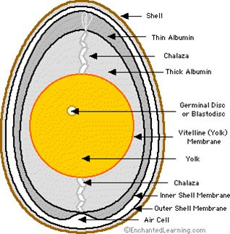
During the demonstration, record suggestions for successful lab experiences, noting any modifications that you would prefer. (eg. Omit ingredients that you don’t like; substitute for allergies etc). Plan with your partner when you will come to the lab to cook and note this in your planner. Ask questions regarding other activities suggested for this learning guide.

LG Written by
Samouilhan / Dmitrieff,
updated: 2019
Activity 1 - The Nutritional value of eggs
Task Purpose: What dietary benefits are there in the nutritional content of eggs?

Use the following resources to answer the questions below:
On using Nutritional Fact tables:
- Health Canada Nutritional facts tables website
(Google: Health Canada Nutrition facts tables)
www.canada.ca/en/health-canada/services/understanding-food-labels/nutrition-facts-tables.html
On what different kinds of nutrients do:
- Food For Life, Chapter 14 (pg 312 – 327)
Check-out in the THSS library.

On the difference between nutrient value of egg white vs. egg yolk
- Youtube video:
PictureFit | Are Egg Yolks Bad For You? - What You've Heard Might Not Be True
www.youtube.com/watch?v=Lbw66b5Glwo

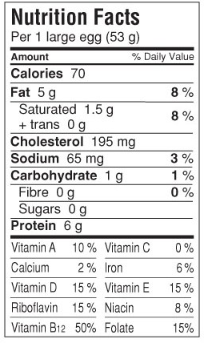
- Use the Nutritional facts box below to identify what information it contains.
(Health Canada website listed above is a good source)
  - What is “serving size” is for eggs?

  - The “g” and “mg” refers to a measurement.
What do these measurements of each nutrients stand for?

  - What is the % daily value referring to?

- What are the jobs of each of the nutrients in an egg?
Make sure to include: Fat (saturated), Cholesterol, Sodium, Carbohydrates (Sugar), Protein, Vitamin A & Calcium.
(Use the Food for Life, Chapter 14 and/or the bottom of the Health Canada Nutritional facts tables website section, labeled: Interactive nutrition facts table).

- What are the differences in the nutrients found in the Egg White vs. Egg Yolk?
Complete the following table:

(The YouTube video by PictureFit “Are Egg Yolks Bad For You?” is a good resource)

Egg White Nutrients | Egg Yolk Nutrients

